SiEPIC_EBeam_PDK Documentation:

Components with Models

All the components included in this document have compact models, are embedded into the SiEPIC_EBeam_PDK in KLayout under the **EBeam - Components with Models** Library, and have Lumerical Interconnect compact models for simulation.

# **Table of Contents**

Table of Contents

[Template] Component Name

Description

Model Name

Compact Model Information

Parameters

Simulation Results

Experimental Results

Additional Details

Reference

Adiabatic Coupler

Bragg Gratings

Broadband Directional Coupler

Crossing

Directional Coupler

Disconnected Waveguide

Fibre Grating Coupler

Ring Resonator

Taper

Terminator

Waveguide

Y-Branch

Appendix A: List of Compact Model Names

# 

# [Template] Component Name

## Description

[Description]

## Model Name

[Model Name]

[Image_of_Component]

Fig. 1: Compact Model of [Component_Name]

## Compact Model Information

* Support for [TE, TM, or TE and TM] polarization
* Operating at [nm] wavelength
* Performance (Insertion Loss, 3dB Bandwidth):
  + TE – TBD
  + TM - TBD

**[Insert SEM Picture & other relevant photos of model]**

Fig. 2: SEM Picture of [Component_Name]

## Parameters

|  |  |  |
| --- | --- | --- |
| **Parameter** | **Default Value** | **Notes** |
|  |  |  |

## Simulation Results

From [Source]:

**[Insert Simulation Results]**

Fig. 3: Simulation Results for [Insert_Details]

## Experimental Results

From [Source]:

**[Insert Experimental Results]**

Fig. 4: Experimental Results for [Insert_Details]

## Additional Details

* Design tools & methodology:

## Reference

# 

# Adiabatic Coupler

*Last Updated: August 2019*

## Description

50/50% 2×2 broadband adiabatic 3-dB couplers/splitters. Two 3-dB couplers can be used to make an unbalanced Mach-Zehnder Interferometer (MZI), showing a large extinction ratio. The advantage of this device compared to the Y-Branch is that it has 2x2 ports, thus the MZI has two outputs. Compared to the directional coupler, it is less wavelength sensitive.

## Model name

Ebeam_adiabatic_te1550 & ebeam_adiabatic_tm1550

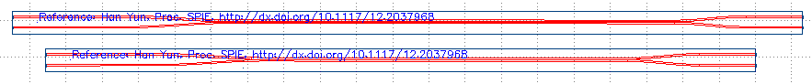

Fig. 1: Compact Model of Adiabatic Coupler (Above: TE Polarization, Below: TM Polarization)

## Compact Model Information

* Support for TE and TM polarization using their respective models
* Operating at 1550 nm wavelength
* Performance:
  + TE – TBD
  + TM - TBD
* For use with strip waveguides only
* Splitting ratio was extracted from the unbalanced MZI spectra.
* Excess loss negligible

## Parameters

N/A

## Simulation Results

From [Source]:

**[Insert Simulation Results]**

Fig. 3: Simulation Results for Adiabatic Couplers

## 

## Experimental Results

From [Source]:

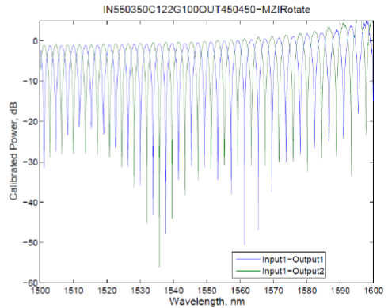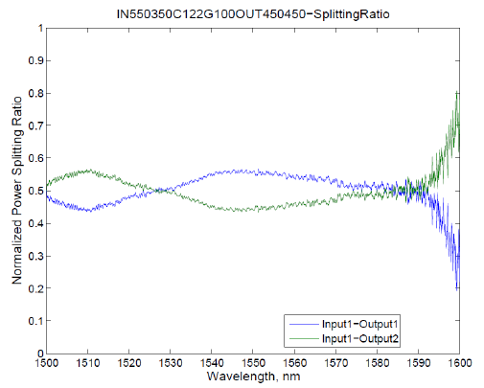

Fig. 4: Experimental Results for Adiabatic Couplers

## Additional Details

* Design tools & methodology:
  + 3D-FDTD (Lumerical FDTD Solutions)
  + Eigenmode expansion propagator (MODE Solutions)

## Reference

1. Han Yun, et al., "2×2 Adiabatic 3-dB Coupler on Silicon-on-Insulator Rib Waveguides", Proc. SPIE, Photonics North 2013, vol. 8915, pp. 89150V, 06/2013 <http://dx.doi.org/10.1117/12.2037968>

# 

# Bragg Gratings

*Last Updated: August 2019*

## Description

Uniform waveguide Bragg gratings, 1st order, TE polarization. This design provides a simple method of varying the grating strength (kappa) by changing the corrugation width (0 to 150 nm) and/or grating misalignment. The gratings can be either rectangular or sinusoidal (sinusoidal have more predictable performance).

## Model Name

ebeam_bragg_te1550



Fig. 1: Compact Model of Bragg Gratings

## Compact Model Information

* Support for TE polarization
* Operating at 1550 nm wavelength
* Performance:
  + TE – TBD
* Grating misalignment:
  + Kappa ranging from ~0 to 140,000 m-1, for a fixed ∆W = 50 nm, with misalignment technique
  + Measured with oxide cladding.
* Number of fabrication iterations (separate runs) to get to published results: 1
* Number of variations fabricated: 10

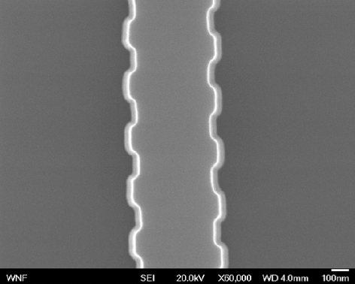

Fig. 2: SEM Picture of Bragg Gratings

## 

## Parameters

|  |  |  |
| --- | --- | --- |
| **Parameter** | **Default Value** | **Notes** |
| Number of Grating Periods | 300 |  |
| Grating Period (microns) | 0.317 |  |
| Corrugation Width (microns) | 0.05 |  |
| Grating Misalignment (microns) | 0 |  |
| Grating Type | False | False = Rectangular True = Sinusoidal |
| Waveguide Width (microns) | 0.5 |  |

## Simulation and Experimental Results

From Xu Wang, et al., "Precise control of the coupling coefficient through destructive interference in silicon waveguide Bragg gratings":

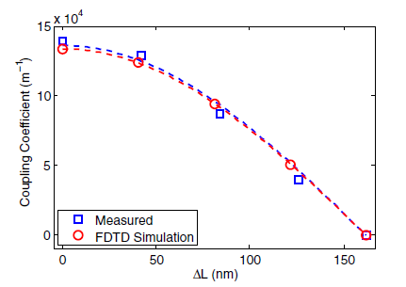

Fig. 3: Simulation and Experimental Results for Coupling Coefficients as a Function of misalignment Length for Gratings with Fixed Corrugation Width (∆W = 50 nm)

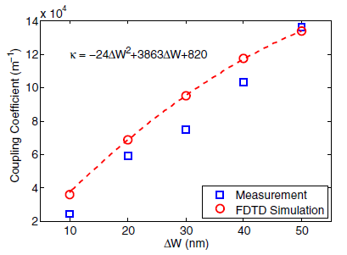

Fig. 4: Simulation and Experimental Results for Coupling Coefficients as a Function of Corrugation Width for Gratings with No Misalignment (∆L = 0)

From Ajay Mistry:

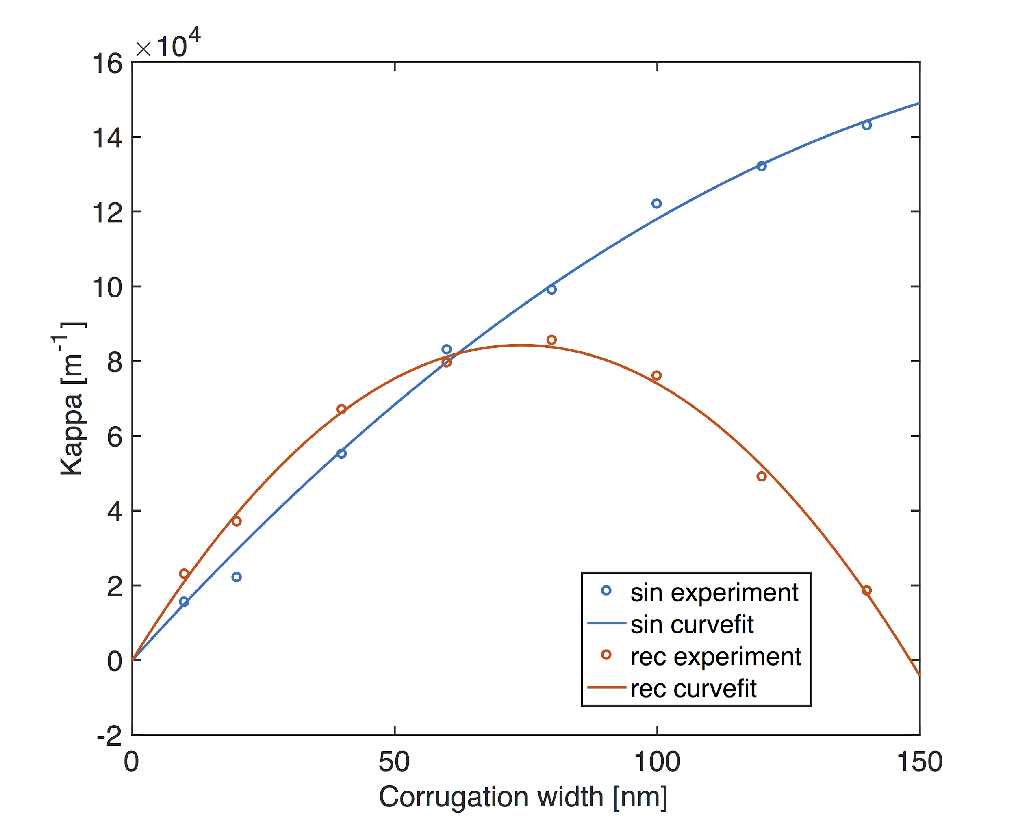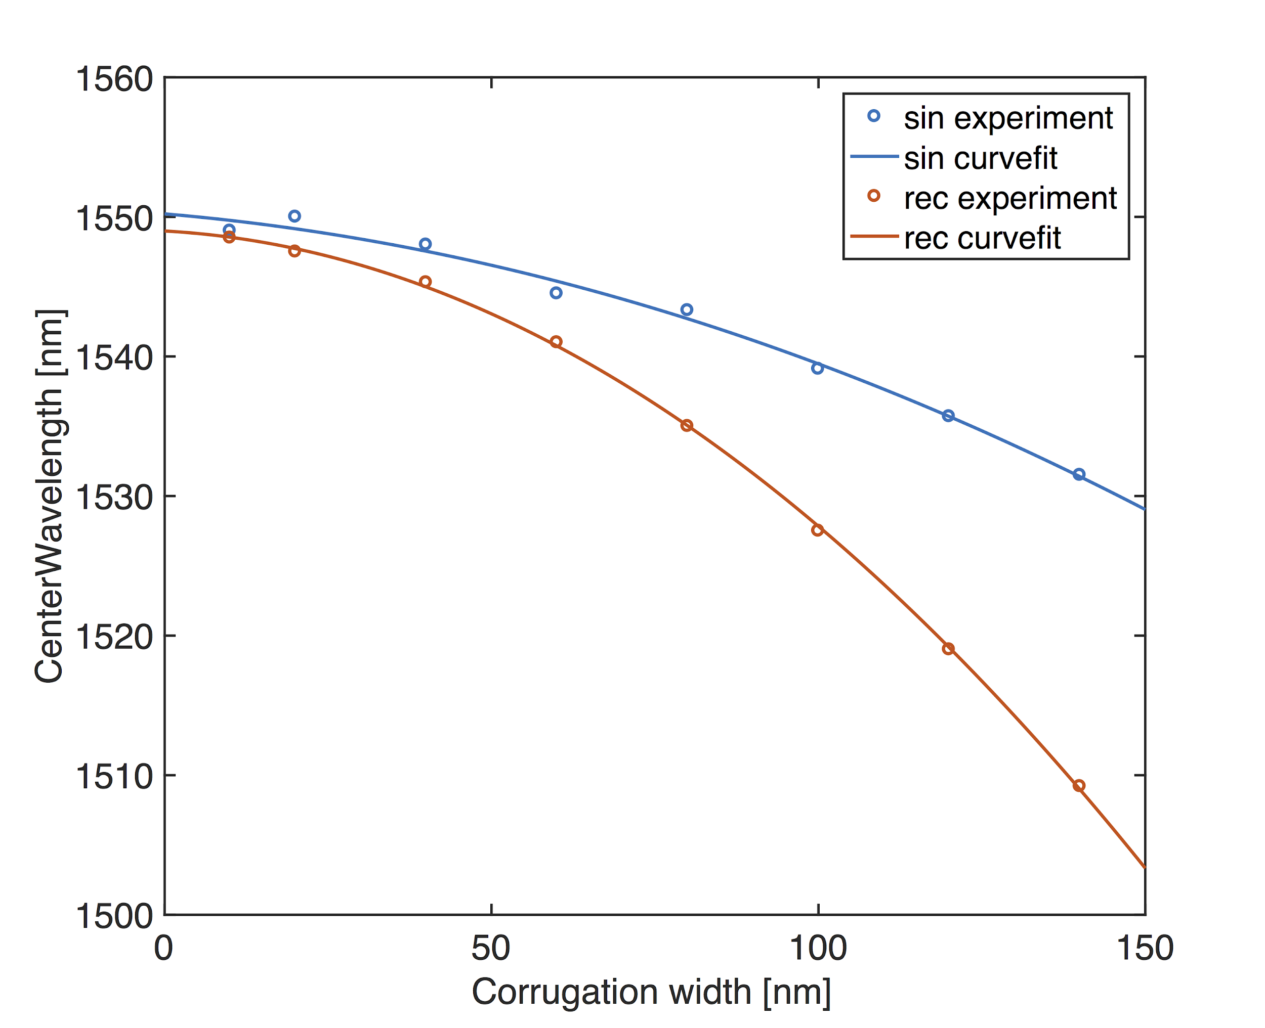

## 

## Additional Details

* Design tools & methodology:
  + Hand-drawn layout (kLayout)
  + Post-fabrication modeling using band-structure calculation in 3D-FDTD (Lumerical FDTD Solutions)
* Measurement Data from 11/2017 Fabrication Run by Applied Nanotools: <https://github.com/lukasc-ubc/edX-Phot1x/tree/master/2017_Bragg_grating>

## Reference

1. Xu Wang, et al., "Precise control of the coupling coefficient through destructive interference in silicon waveguide Bragg gratings", Optics Letters, vol. 39, issue 19, pp. 5519-5522, 10/2014 <http://dx.doi.org/10.1364/OL.39.005519>

# Broadband Directional Coupler

*Last Updated: August 2019*

## Description

50/50% broadband directional 3-dB couplers. Two 3-dB couplers can be used to make an unbalanced Mach-Zehnder Interferometer (MZI), showing a large extinction ratio. The advantage of this device compared to the Y-Branch is that it has 2x2 ports, thus the MZI has two outputs. Compared to the directional coupler, it is less wavelength sensitive.

## Model Name

ebeam_bdc_te1550

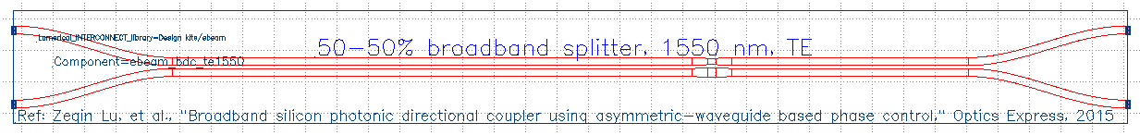

Fig. 1: Compact Model of a Broadband Directional Coupler

## Compact Model Information

* Support for TE polarization
* Operating at 1550 wavelength
* Performance (Insertion Loss, 3dB Bandwidth):
  + TE – TBD
* Splitting ratio was extracted from the unbalanced MZI spectra.
* Excess loss negligible

**[Insert SEM Picture & other relevant photos of model]**

Fig. 2: SEM Picture of [Component_Name]

## Parameters

N/A

## Simulation Results

From [Source]:

**[Insert Simulation Results]**

Fig. 3: Simulation Results for [Insert_Details]

## Experimental Results

From [Source]:

**[Insert Experimental Results]**

Fig. 4: Experimental Results for [Insert_Details]

## 

## Additional Details

* Design tools & methodology:
  + MATLAB
  + 3D-FDTD (Lumerical FDTD Solutions)
  + Eigenmode expansion propagator (MODE Solutions)

## Reference

1. Zeqin Lu, Han Yun, Yun Wang, Zhitian Chen, Fan Zhang, Nicolas A. F. Jaeger, Lukas Chrostowski, "Broadband silicon photonic directional coupler using asymmetric-waveguide based phase control", Opt. Express, vol. 23, issue 3: OSA, pp. 3795--3808, 02/2015, <http://www.opticsexpress.org/abstract.cfm?URI=oe-23-3-3795>

# 

# Crossing

*Last Updated: August 2019*

## Description

Crossings are used to support the routing of more complex photonic circuits. Improvement to the waveguide’s transmission can be achieved by reducing diffraction that occurs in the component’s centre crossing region. To widen the waveguide’s core, elliptical mode expanders are used for this component.

## Model Name

ebeam_crossing4

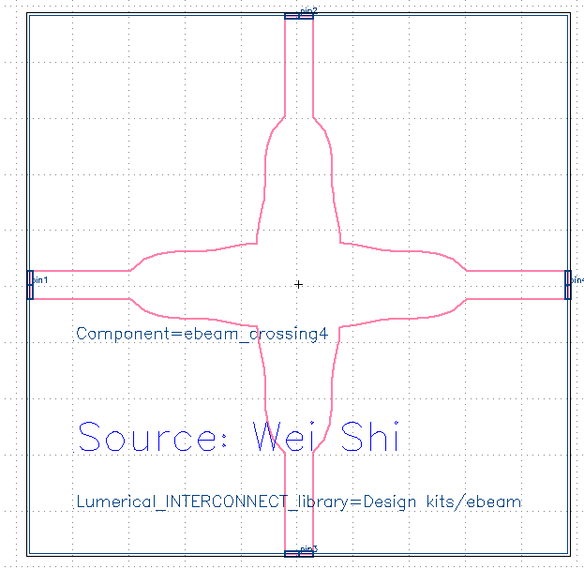

Fig. 1: Compact Model of Crossing

## Compact Model Information

* Support for TE and TM polarization
* Operating at 1550 nm wavelength
* Performance:
  + Transmission loss: < 0.2 dB
  + Crosstalk and reflection: < 40 dB in a broad bandwidth of 20 nm
* Implemented by Wei Shi in 2011 based on “Highly efficient crossing structure for silicon-on-insulator waveguides”
* Similarly fabricated by OpSIS and published with test results in “A CMOS-Compatible, Low-Loss, and Low-Crosstalk Silicon Waveguide Crossing”

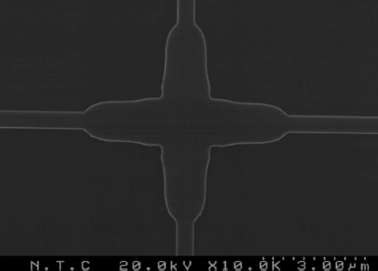

Fig. 2: Optical Micrograph Picture of Crossing

## Parameters

N/A

## Simulation and Experimental Results

* Not tested with EBeam

From P. Sanchis et al.:

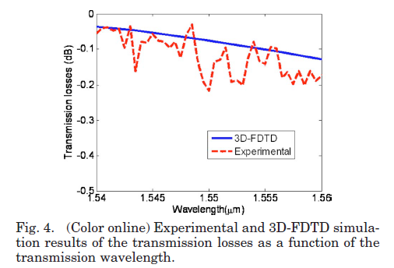

Fig. 4: Experimental Results for Crossing

## Additional Details

* Potential Usage
  + 2x2 splitter/combiner, with adjustable coupling coefficient
  + Ring resonator
  + Mach-Zehnder Interferometer

## Reference

1. P. Sanchis, et al., Highly efficient crossing structure for silicon-on-insulator waveguides, Opt. Lett., vol. 34, no. 18, pp. 2760-2762, 2009.
2. Yi Zhang, Shuyu Yang, Andy Eu-Jin Lim, Guo-Qiang Lo, Christophe Galland, Tom Baehr-Jones, and Michael Hochberg, "A compact and low loss Y-junction for submicron silicon waveguide," Opt. Express 21, 1310-1316 (2013)

# Directional Coupler

*Last Updated: August 2019*

## Description

The directional coupler is commonly used for splitting and combining light in photonics. It consists of two parallel waveguides where the coupling coefficient is influenced by the waveguide length and the distance between waveguides.

## Model Name

ebeam_dc_te1550

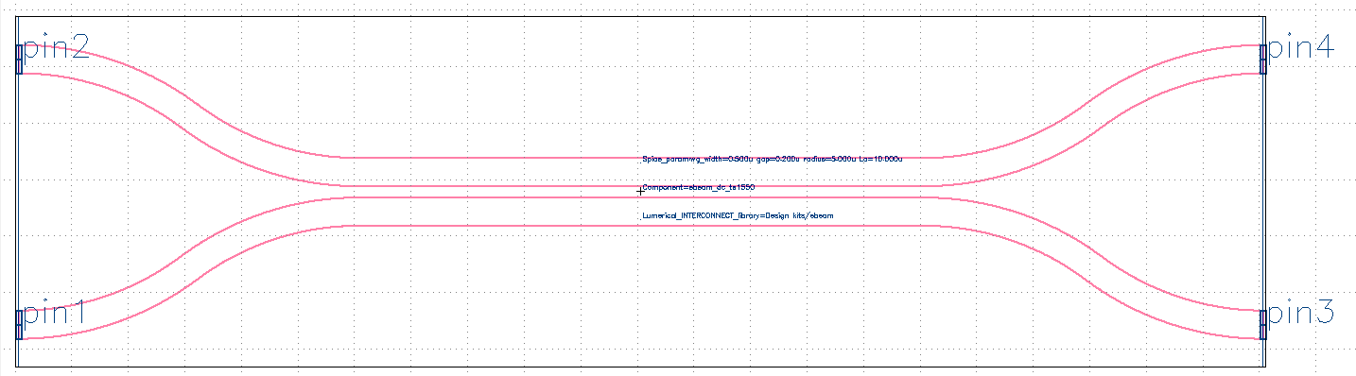

Fig. 1: Compact Model of a Directional Coupler

## Compact Model Information

* Support for TE polarization
* Operating at 1550 nm wavelength
* Performance:
  + TE – TBD
  + TM - TBD

**[Insert SEM Picture]**

Fig. 2: SEM Picture of a Directional Coupler

## Parameters

|  |  |  |
| --- | --- | --- |
| **Parameter** | **Default Value** | **Notes** |
| Coupler Length | 10 |  |

## Simulation Results

From [Source]:

**[Insert Simulation Results]**

Fig. 3: Simulation Results for Directional Coupler

## Experimental Results

From [Source]:

**[Insert Experimental Results]**

Fig. 4: Experimental Results for Directional Coupler

## Additional Details

* Design tools & methodology:

## Reference



# 

# Disconnected Waveguide

*Last Updated: August 2019*

## Description

This component is a non-physical component that represents a broken or unterminated waveguide when simulated in Lumerical Interconnect. This component models what happens for a blunt waveguide ending (500 x 220 nm). Such a disconnect is identified as an error during layout verification, however, this effect is included in the Library for completeness to understand what happens when a port is left disconnected.

This model is automatically used to simulate what happens when a component's pins are not terminated (see Terminator) or otherwise connected. INTERCONNECT assumes that there is no reflection from disconnected ports; the assumption is that there is a perfect matching between the component and whatever is outside (perfectly absorbing). This isn't physically correct. To account for the reflections from disconnected ports, the SiEPIC PDK in KLayout automatically adds this component to every disconnected port found in the layout.

## Model Name

ebeam_disconnected_te1550 & ebeam_disconnected_tm1550

## Compact Model Information

* Support for TE and TM polarization using their respective models
* Operating at 1550 nm wavelength
* One port

## Additional Details

* Design tools & methodology:
  + Modelled by 3D FDTD with data saved as S11 parameters

# 

# Fibre Grating Coupler

*Last Updated: August 2019*

## Description

Fully-etched fibre-waveguide grating couplers with sub-wavelength gratings showing high coupling efficiency as well as low back reflections for both transverse electric (TE) and transverse magnetic (TM) modes. EBeam fabrication cost is reduced by ~2-3X when eliminating the shallow etch.

## Model Name

ebeam_gc_te1550 & ebeam_gc_tm1550

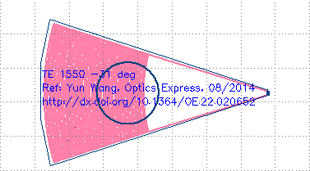

Fig. 1: Compact Model of Grating Coupler

## 

## Compact Model Information

* Support for TE and TM polarization using their respective models
* Operating at 1550 nm wavelength
* Performance:
  + TE – 4.1 dB loss, 30.6 nm 1-dB bandwidth
  + TM – 3.7 dB loss, 47.5 nm 1-dB bandwidth

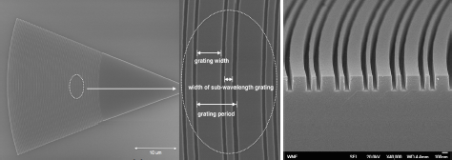

Fig. 2: SEM Picture of the Focusing Sub-wavelength Grating Coupler - Top View  
Fig. 3: SEM Picture of the Focusing Sub-wavelength Grating Coupler - Sidewall View

## Parameters

N/A

## 

## Simulation Results

From [Source]:

Extinction Ratios

* TE - 0.3 dB
* TM - 0.15 dB

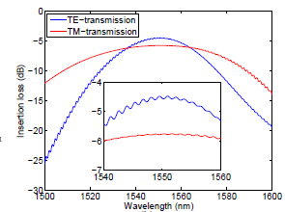

Fig. 4: Simulation Transmission Spectra of Input-Waveguide-Output Circuits for Sub-Wavelength Grating Couplers for TE (blue line) and TM (red line) Modes

## Experimental Results

|  |  |  |
| --- | --- | --- |
| Coupler Type | Publication | Details |
| Uniform | Yun Wang, et al., “Focusing sub-wavelength grating couplers with low back reflections for rapid prototyping of silicon photonic circuits”, Optics Express, 2014 | * Fully-etched fiber-waveguide grating couplers with sub-wavelength gratings. * TE – 4.1 dB loss, 30.6 nm 1-dB bandwidth, -25º incident angle. * TM – 3.7 dB loss, 47.5 nm 1-dB bandwidth, 10º incident angle. * Repeatable results |
| Apodized | Yun Wang, et al., “Apodized focusing fully etched sub-wavelength grating couplers”, Photonics Journal, 2015 | * Reduced insertion loss. * TE – 3.2 dB loss, 36 nm 1-dB bandwidth, -24 dB back reflections, -31º incident angle * TM – 3.3 dB loss, 37 nm 1-dB bandwidth, -21 dB back reflections, 10º incident angle * Less repeatable results |
| Broadband | Yun Wang, et al., “Design of Broadband Sub-Wavelength Grating Couplers with Low Back Reflection”, Optics Letters, 2015 | * Increased bandwidth, but slightly lower coupling efficiency * TE – 3.8 dB loss, 90nm 1-dB bandwidth, -23 dB back reflections, 25º incident angle * TM – no performance information * Small Fabry-Perot ripples 0.08 dB due to the low reflections (-23 dB) * Repeatable results |

## Additional Details

* Incremental Fabrication Cost: $0.02 each on Layer 1
* Design Tools & Methodology: 2D & 3D FDTD (Lumerical Solutions), Scripted mask layout (Mentor Graphics Pyxis)
* Support for Monte Carlo using wafer map
* Model uses S-Parameters generated for 9 variations
* Number of fabrication iterations (separate runs) to get to published results: 6
* Number of variations fabricated: 100+

## Reference

1. Yun Wang, et al., "Focusing sub-wavelength grating couplers with low back reflections for rapid prototyping of silicon photonic circuits", Optics Express, vol. 22, no. 17: OSA, pp. 20652-20662, 08/2014, <http://dx.doi.org/10.1364/OE.22.020652>
2. Yun Wang, et al., “Apodized focusing fully etched sub-wavelength grating couplers”, Photonics Journal, 2015
3. Yun Wang, et al., “Design of Broadband Sub-Wavelength Grating Couplers with Low Back Reflection”, Optics Letters, 2015
4. Yun Wang, et al., “Compact single-etched sub-wavelength grating couplers for O-band application”, Optics Express, 2017

# 

# Ring Resonator

*Last Updated: August 2019*

## Description

Useful for filters, sensors, etc. and to extract fabrication non-uniformity.

## Model Name

ebeam_dc_halfring_straight

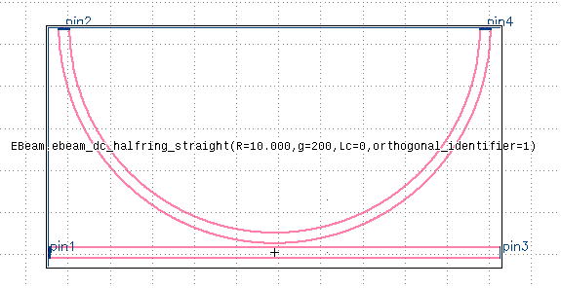

Fig. 1: Compact Model of Half Ring Resonator

## Compact Model Information

* Support for TE and TM polarization using the respective orthogonal identifier parameter
* Performance:
  + Found that for EBeam process with existing wafer stock, the wavelength variation for resonators across the chip was +/- 3 nm. Grating coupler insertion loss varied by +/- 1.5 dB.
  + Un-optimized ring: Line-width = 40 pm; Extinction Ratio = 6 dB

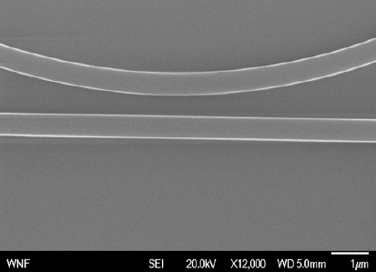

Fig. 2: SEM Picture of Ring Resonator

## 

## 

## Parameters

|  |  |  |
| --- | --- | --- |
| **Parameter** | **Default Value** | **Notes** |
| Radius (microns) | 10 |  |
| Waveguide Width (microns) | 0.5 |  |
| Gap (microns) | 0.2 |  |
| Coupler Length (microns) | 0 |  |
| Orthogonal Identifier | 1 | 1 = TE, 2 = TM |

## Simulation Results

From [Source]:

**[Insert Simulation Results]**

Fig. 3: Simulation Results for Ring Resonator

## Experimental Results

From L. Chrostowski, et al., "Impact of Fabrication Non-Uniformity on Chip-Scale Silicon Photonic Integrated Circuits", Optical Fiber Conference, 2014:

* Negative linear relationship between group index and resonant wavelength
* Grating couplers are primarily sensitive to etch depth

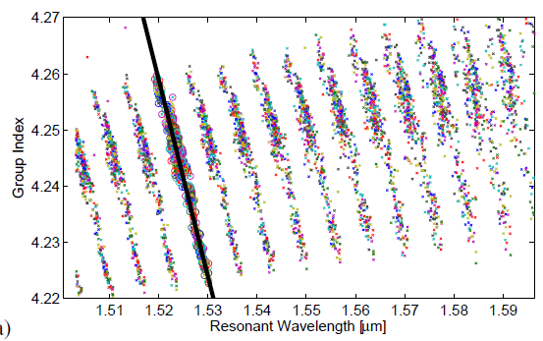

Fig. 3: Extracted Group Index Versus Resonance Wavelength for All Experimented Resonators

## Additional Details

* Design Tools & Methodology: Eigenmode (Lumerical Solutions), Scripted mask layout (Mentor Graphics Pyxis)

## Reference

1. L. Chrostowski, et al., "Impact of Fabrication Non-Uniformity on Chip-Scale Silicon Photonic Integrated Circuits", Optical Fiber Conference, 2014<http://dx.doi.org/10.1364/OFC.2014.Th2A.37>

# Taper

*Last Updated: August 2019*

## Description

Tapers are used to connect devices with different waveguide widths to prevent loss and ensure a smaller area for waveguide transitions. The taper length is dependent on the indicated waveguide widths.

## Model Name

ebeam_taper_te1550

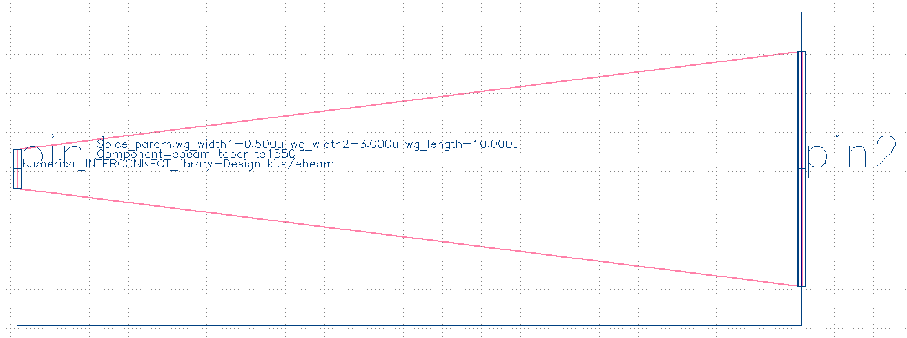

Fig. 1: Compact Model of Taper

## Compact Model Information

* Support for TE polarization
* Operating at 1550 nm wavelength
* Performance:
  + TE – TBD
  + TM - TBD

**[Insert SEM Picture & other relevant photos of model]**

Fig. 2: SEM Picture of Taper

## Parameters

|  |  |  |
| --- | --- | --- |
| **Parameter** | **Default Value** | **Notes** |
| Waveguide Width1 | 0.5 | CML only supports 0.4, 0.5, 0.6 |
| Waveguide Width2 | 3 | CML only supports 1, 2, 3 |
| Waveguide Width Length | 10 | CML only supports a range of 1-10 |

## 

## Simulation Results

From [Source]:

**[Insert Simulation Results]**

Fig. 3: Simulation Results for Taper

## Experimental Results

From [Source]:

**[Insert Experimental Results]**

Fig. 4: Experimental Results for Taper

## Additional Details

* Design tools & methodology:

## Reference

# 

# Terminator *Last Updated: August 2019*

## Description

This component is used to terminate a waveguide. This terminator is a nano-taper that spreads the light into the oxide and is used for efficient edge coupling. Even if a waveguide crosses near this taper end, the reflection is minimal. This is included in this model, 1 µm away, therefore, the model is a worst-case reflection. To terminate unused ports on components to avoid reflections, refer to Disconnected Waveguides.

## Model Name

ebeam_terminator_te1550 & ebeam_terminator_tm1550

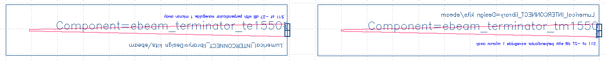

Fig. 1: Compact Model of TE and TM Terminators

## Compact Model Information

* Support for TE and TM polarization using their respective models
* Operating at 1550 nm wavelength
* Performance:
  + TE – TBD
  + TM - TBD

**[Insert SEM Picture & other relevant photos of model]**

Fig. 2: SEM Picture of Terminator

## Parameters

N/A

## Simulation Results

From [Source]:

**[Insert Simulation Results]**

Fig. 3: Simulation Results for Terminator

## Experimental Results

From [Source]:

**[Insert Experimental Results]**

Fig. 4: Experimental Results for Terminator

## Additional Details

* Design tools & methodology:

## Reference

# 

# Waveguide

*Last Updated: August 2019*

## Description

Waveguides are components that guide waves. Although these are individual components that can be adjusted for use, it is recommended to draw paths in KLayout and convert them to waveguides using the built-in SiEPIC features.

Waveguide_bump is specifically used to make a slightly longer waveguide within the same amount of space, e.g., 20 µm, plus 50 nm.

## Model Name

Waveguide & Waveguide_Bend & Waveguide_SBend & Waveguide_Straight & Waveguide_bump

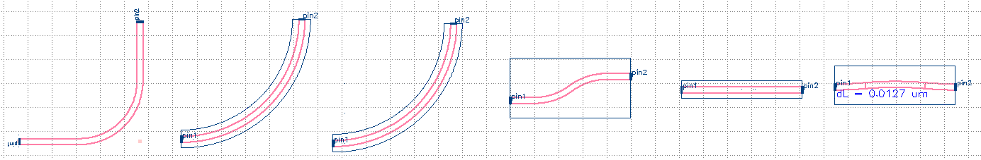

Fig. 1: Compact Model of all Corresponding Models   
(L to R): Waveguide & Waveguide_Bend & Waveguide_SBend & Waveguide_Straight & Waveguide_bump

## Compact Model Information

* Support for TE and TM polarization
* Operating around 1550 nm wavelength
* Performance (September 2019 from <https://www.appliednt.com/nanosoi/>):

|  |  |  |
| --- | --- | --- |
| Polarization | Straight Waveguide Loss | Curved Waveguide Loss |
| TE | 1.5 dB/cm | 3.8 dB/cm |
| TM | 2.4 dB/cm | 3.0 dB/cm |

* Waveguide Width ranging from 0.4 µm to 3.5 µm
  + SiEPIC & UBC researchers typically use 500 nm for TE and TM
* Waveguide Height ranging from 210 to 230 nm
* Drawn in KLayout using Waveguide Type = ROUND_PATH

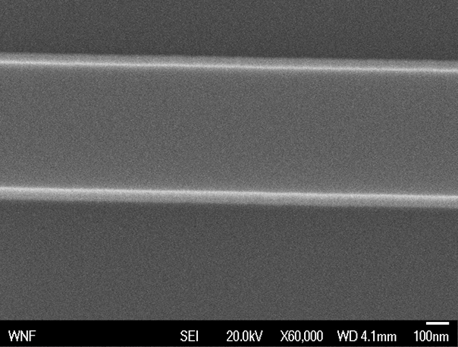

Fig. 2: SEM Picture of Waveguide_Straight

## Parameters

|  |  |  |
| --- | --- | --- |
| **Model Name** | **Parameter** | **Default Value** |
| Waveguide | Radius (microns) | 5 |
|  | Width (microns) | 0.5 |
|  | Adiabatic | No |
|  | Bezier Parameter | 0.35 |
|  | Layers | Waveguide |
|  | Widths (microns) | 0.5 |
|  | Offsets (microns) | 0 |
| Waveguide_Bend | Radius (microns) | 10 |
|  | Waveguide Width (microns) | 0.5 |
| Waveguide_SBend | Waveguide Length (microns) | 10 |
|  | Waveguide Offset Height (microns) | 2 |
|  | Waveguide Width (microns) | 0.5 |
|  | Waveguide Bend Radius (microns) | 5 |
| Waveguide_Straight | Waveguide Length (nm) | 10000 |
|  | Waveguide Width (nm) | 500 |
| Waveguide_bump | Regular Waveguide Length (microns) | 10 |
|  | Waveguide Angle (degrees) | 5 |
|  | Waveguide Width (microns) | 0.5 |

## Simulation Results

From [Source]:

**[Missing Simulation Results]**

Fig. 3: Simulation Results for Waveguides

## Experimental Results

From [Source]:

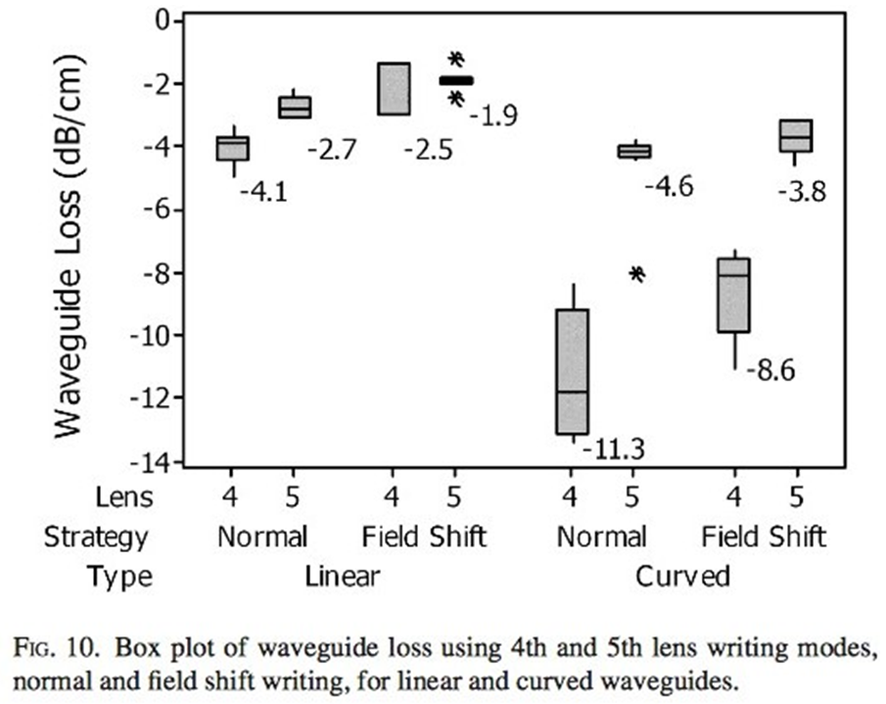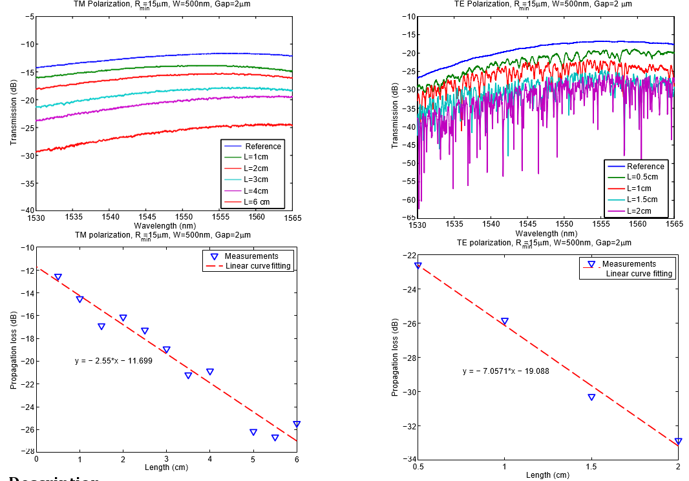

Fig. 4: Experimental Results for Waveguides

## Additional Details

* Support for Monte Carlo using wafer map
* Model uses interpolation for geometries not in the database
* In “Electron beam lithography writing strategies for low loss high confinement silicon optical waveguides,” 400 nm waveguide width was used. A variety of write methods were explored which had trade-offs of write-time vs. loss.
* SiEPIC runs use 4th Lens, 2-pass field shift writing, with default 6 nm shot pitch, 8 nA beam current.
* Design tools & methodology: Cut-back method for determining loss from “Electron beam lithography writing strategies for low loss high confinement silicon optical waveguides”

## Reference

1. R. J. Bojko, J. Li, L. He, T. Baehr-Jones, M. Hochberg, Y. Aida, "Electron beam lithography writing strategies for low loss high confinement silicon optical waveguides", J. Vac. Sci. Technol. B, vol. 29, no. 6, Oct. 2011.
2. Performance Results: <https://www.appliednt.com/nanosoi/>

# 

# Y-Branch

*Last Updated: August 2019*

## Description

50/50% 3dB splitter. Useful for splitting light, Mach-Zehner Interferometers, etc. The layout parameters for the device were taken from the journal paper below, and implemented in EBeam lithography.

## Model Name

ebeam_y_1550

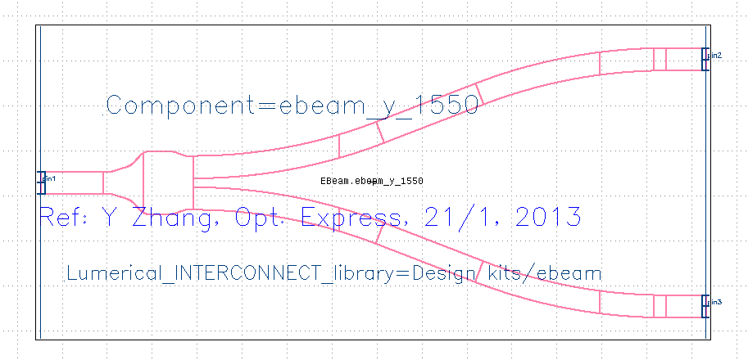

Fig. 1: Compact Model of Y-Branch

## Compact Model Information

* Support for TE polarization
* Operating at 1550 nm wavelength
* Performance:
  + Excess Loss is < 1 dB

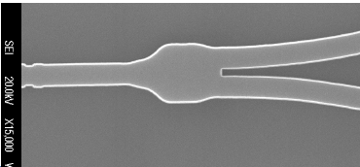

Fig. 2: SEM Picture of Y-Branch

## Parameters

N/A

## Simulation Results

From Y Zhang, et al., “A compact and low loss Y-junction for submicron silicon waveguide”:

* Transmission and reflection are wavelength insensitive

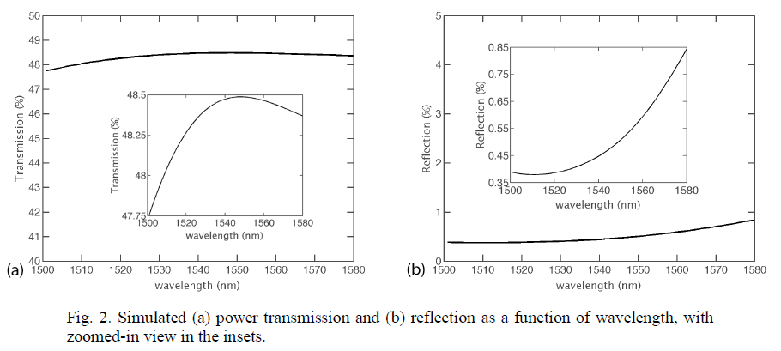

Fig. 3: Simulation Results

## Experimental Results

From Y Zhang, et al., “A compact and low loss Y-junction for submicron silicon waveguide”:

* Insertion loss of 0.28 +/- 0.02 dB, uniform across an 8-inch wafer
* Output power and splitting ratio are uniform and wavelength insensitive

## Additional Details

* Design Tools & Methodology: 2D & 3D FDTD (Lumerical Solutions)

## Reference

1. Y Zhang, et al., “A compact and low loss Y-junction for submicron silicon waveguide”, Opt. Express, 21/1, pp. 1310-1316 (2013) <http://dx.doi.org/10.1364/OE.21.001310>



# Appendix A: List of Compact Model Names

*Located in KLayout Library: EBeam - Components with models [Technology EBeam]*

1. Adiabatic Coupler
   1. ebeam_adiabatic_te1550
   2. Ebeam_adiabatic_tm1550
2. Bragg Grating
   1. ebeam_bragg_te1550
3. Broadband Directional Coupler
   1. Ebeam_bdc_te1550
4. Crossing
   1. Ebeam_crossing4 (UW Dropbox)
5. Directional Coupler
   1. Ebeam_dc_te1550
6. Fibre Grating Coupler
   1. Ebeam_gc_te1550
   2. ebeam_gc_tm1550
7. Ring Resonator
   1. ebeam_dc_halfring_straight
8. Taper
   1. Ebeam_taper_te1550
9. Terminator
   1. Ebeam_terminator_te1550
   2. Ebeam_terminator_tm1550
10. Waveguide
    1. Waveguide
    2. Waveguide_bend
    3. Waveguide_SBend
    4. Waveguide_Straight
    5. Waveguide_bump
11. Y coupler
    1. Ebeam_y_1550